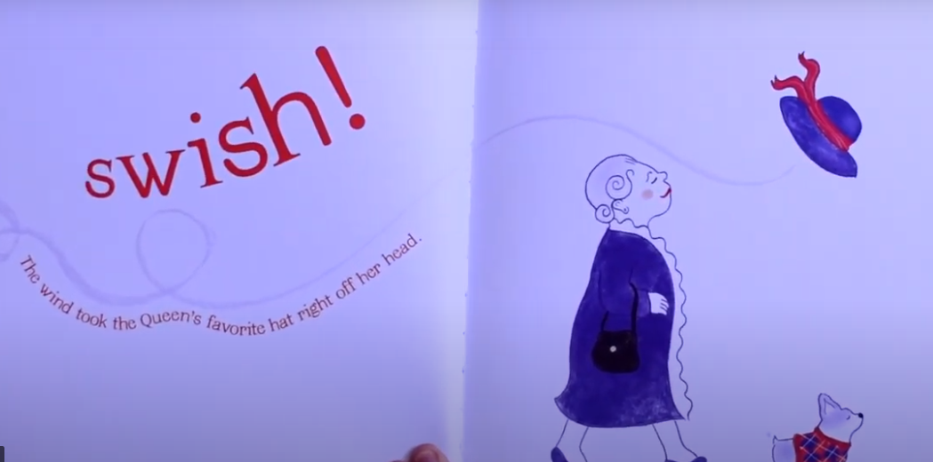

What do you think the queen is thinking/saying?