Reorder the words to make sentences
Spot the –ve word in each sentence

eat | love | chocolate | They | ice | to | cream.

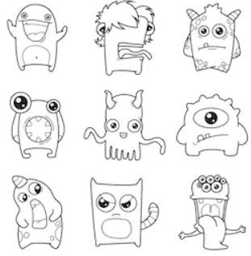

live | These | on | monsters | Planet | yellow | Mars.

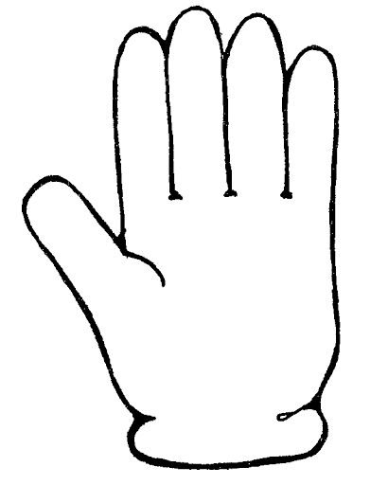

blue | friend | glove | today. | lost | her | My

