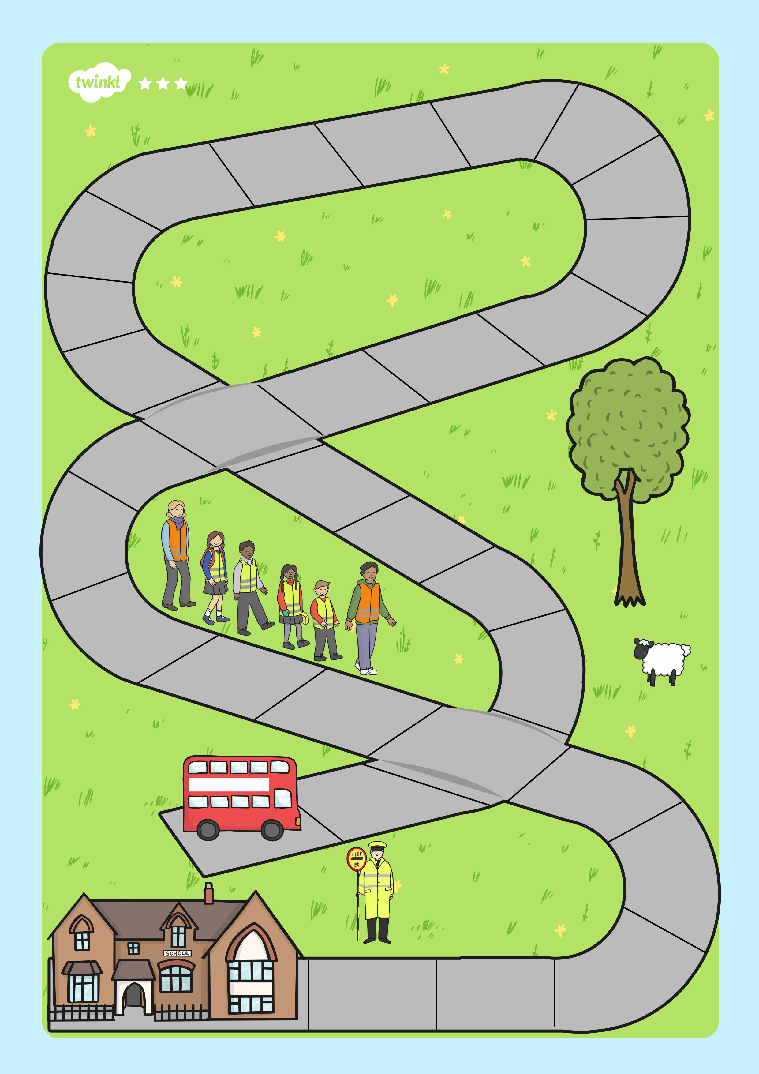
Subtraction to 20 School Bus Ride
11-7
17-9
15-7
13-8
20-12
14-6
14-5
13-4
14-5
15-8
12-3
17-8
20-11
11-6
20-8
16-9
12-8
18-5
17-5
16-7
18-11
13-6
11-9
10-3
12-7
13-7
15-9
19-8
14-9
19-15
start
finish

