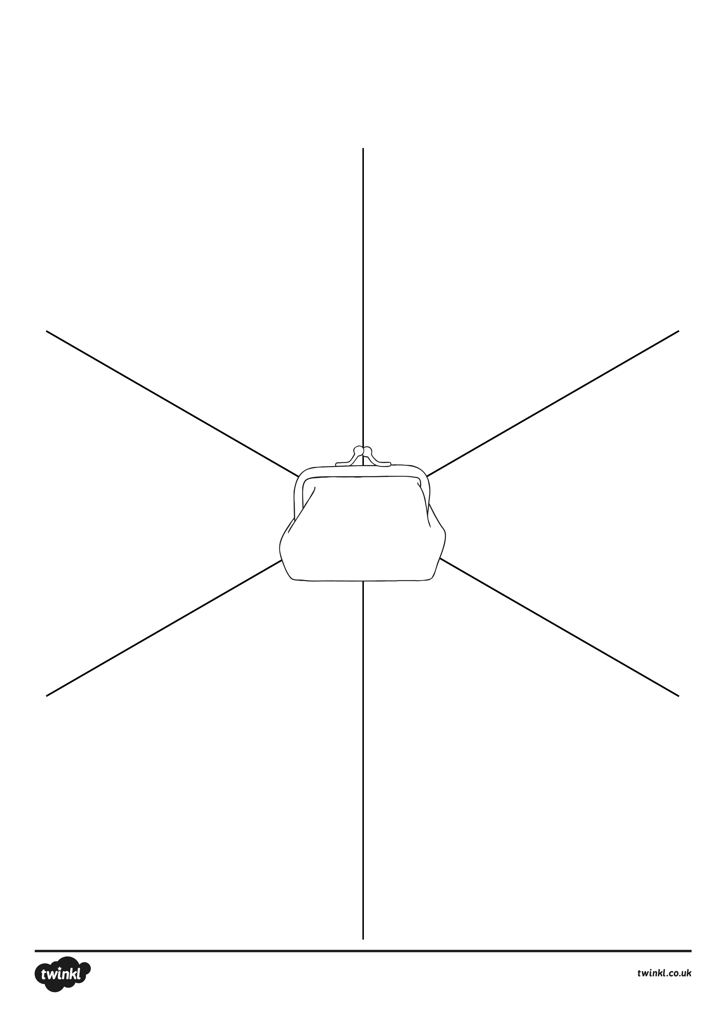
Show Me the Money!
10p
Can you find different ways to make the same amount as the money in the purse?
Show Me the Money!
20p
Can you find different ways to make the same amount as the money in the purse?

