_____________________________________________________

[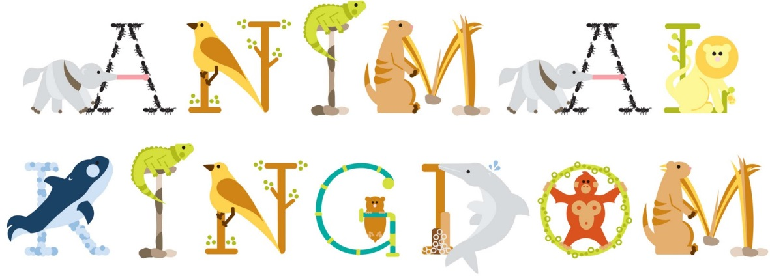](http://www.google.co.uk/url?sa=i&rct=j&q=&esrc=s&source=images&cd=&cad=rja&uact=8&ved=0ahUKEwjZo-i98uHQAhUGbRQKHbSiDvkQjRwIBw&url=http://www.easyfreeclipart.com/animal-kingdom-clipart.html&psig=AFQjCNFp3L0hHcNOdWOOSlC_tET_9X-S1A&ust=1481193621964188)

Book

Date: _________________________

Mammals

Fur Alive Warm Blooded

___________________________________________________________________________________________________________________________________________________________________________________________________________________________________________________________________________________________________________________________________________________________________________________________________________________________________________________________________________________________________________________________________________________

___________________________________________________________

___________________________________________________________

Draw (and label) a picture of a mammal.

Date: _________________________

Reptiles

Scales Eggs Land Cold Blooded:

___________________________________________________________________________________________________________________________________________________________________________________________________________________________________________________________________________________________________________________________________________________________________________________________________________________________________________________________________________________________________________________________________________________

___________________________________________________________

___________________________________________________________

Draw (and label) a picture of a reptile.

Date: _________________________

Birds

Feathers Eggs Warm Blooded

___________________________________________________________________________________________________________________________________________________________________________________________________________________________________________________________________________________________________________________________________________________________________________________________________________________________________________________________________________________________________________________________________________________

___________________________________________________________

___________________________________________________________

Draw (and label) a picture of a bird.

Date: _________________________

Amphibians

Eggs Water Slimy Skin

___________________________________________________________________________________________________________________________________________________________________________________________________________________________________________________________________________________________________________________________________________________________________________________________________________________________________________________________________________________________________________________________________________________

___________________________________________________________

___________________________________________________________

Draw (and label) a picture of an amphibian.

Date: _________________________

Fish

Scales Water Eggs ___________________________________________________________________________________________________________________________________________________________________________________________________________________________________________________________________________________________________________________________________________________________________________________________________________________________________________________________________________________________________________________________________________________

___________________________________________________________

___________________________________________________________

Draw (and label) a picture of a fish.



End of Unit Assessment

Can you colour…

Mammals – Blue

Fish – Purple

Birds – Red

Amphibians – Green

Reptiles - Orange