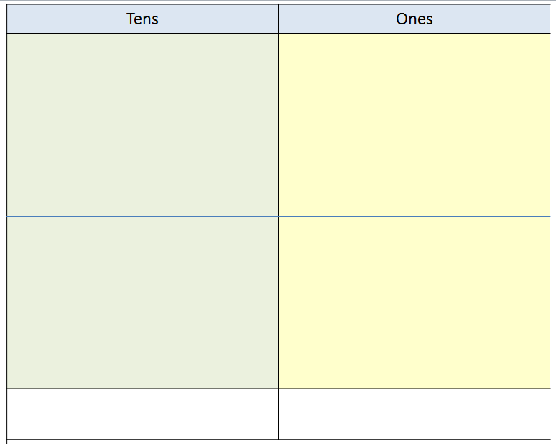

14 + 14 =

10 + 16 =

11 + 16 =

12 + 13 =

Name_________________________________________________________________________ Date____________________

Adding a 2 digit numbers