Autumn 1 | 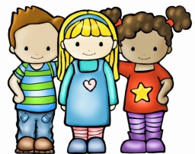  “Me, myself and I” | This topic allows the children to get to know one another and themselves. We look at families, bodies, homes and special memories. The children love to share exciting facts about themselves and we largely focus on personal, social and emotional development. During this half term we support children in making friends, follow routines and settle into life at school.
Autumn 2 | 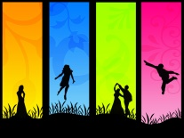  “Colour” | This topic is ideal for this time of year. It focusses on environmental colour changes in Autumn and Winter, mixing colours and reading lots of colourful stories! This topic includes seasonal walks around the local area to see some wonderful colours for ourselves. This half term leads into Christmas, with performances and other events taking place.
Spring 1 & 2 | “The Universe we share” | This topic is spread over the whole spring term. It focusses on exploring the World including space, weather, continents, countries, planets and animals. The children’s interests will develop and may include things like building rockets, making alien jelly and developing our scientific knowledge.
Summer 1 & 2 | 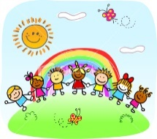  “Let’s go outside” | This topic is all about being outside and enjoying the Summer. We will explore different settings such as the beach, gardens and forests. During this term the children may enjoy planting, hunting for minibeasts, investigating the weather and creating. We will enhance the topic with a trip as well as enjoying forest schools during this term.
The wonderful thing about the EYFS curriculum is that it is specifically designed to work around the interests and needs of the children in each class.
We use broad topics so that we can follow the interests and passions of the children across the year. We want them to take the lead to ensure they engage with the curriculum. This is achieved through “In the Moment Planning” techniques.

